***Estimation of Business Expenses***

**INTRODUCTION:**

**Overview:**

**There are a number of different types of business expenses you can incur, and each has its own rules and guidelines. The first type of business expense is the direct cost. This consists of costs associated with your  business's actual running, like salaries, rent, and utilities.**

**Purpose:**

**An expense in the cost of operations that a company incurs to generate revenue.Business expenses are the costs businesses must pay to fund their operation. Business expenses are deducted from revenue to arrive at profts.**

**Problem Definition & Design Thinking:**

**EMPATHY MAP**

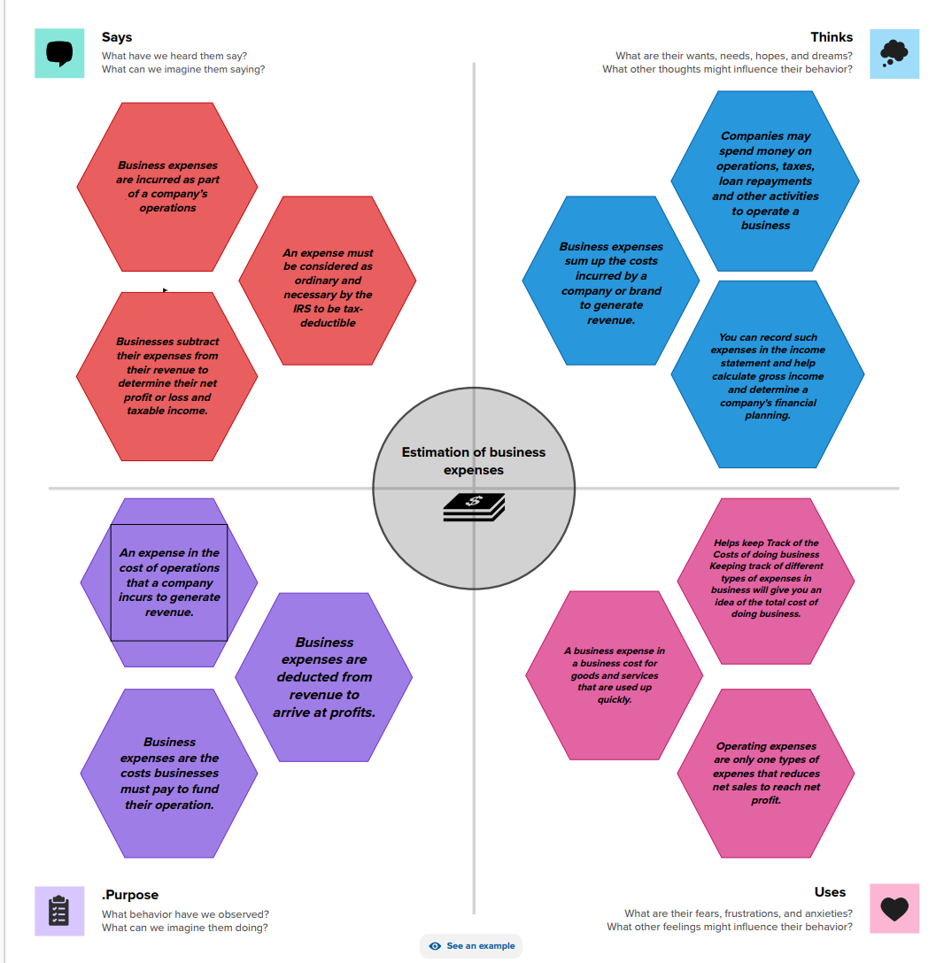

**Ideation & Brainstroming Map**

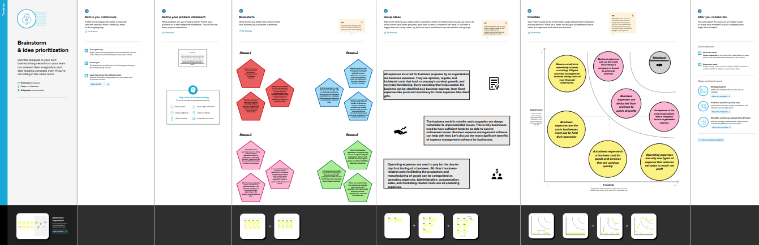

**RESULT**

**Dashboard 1**

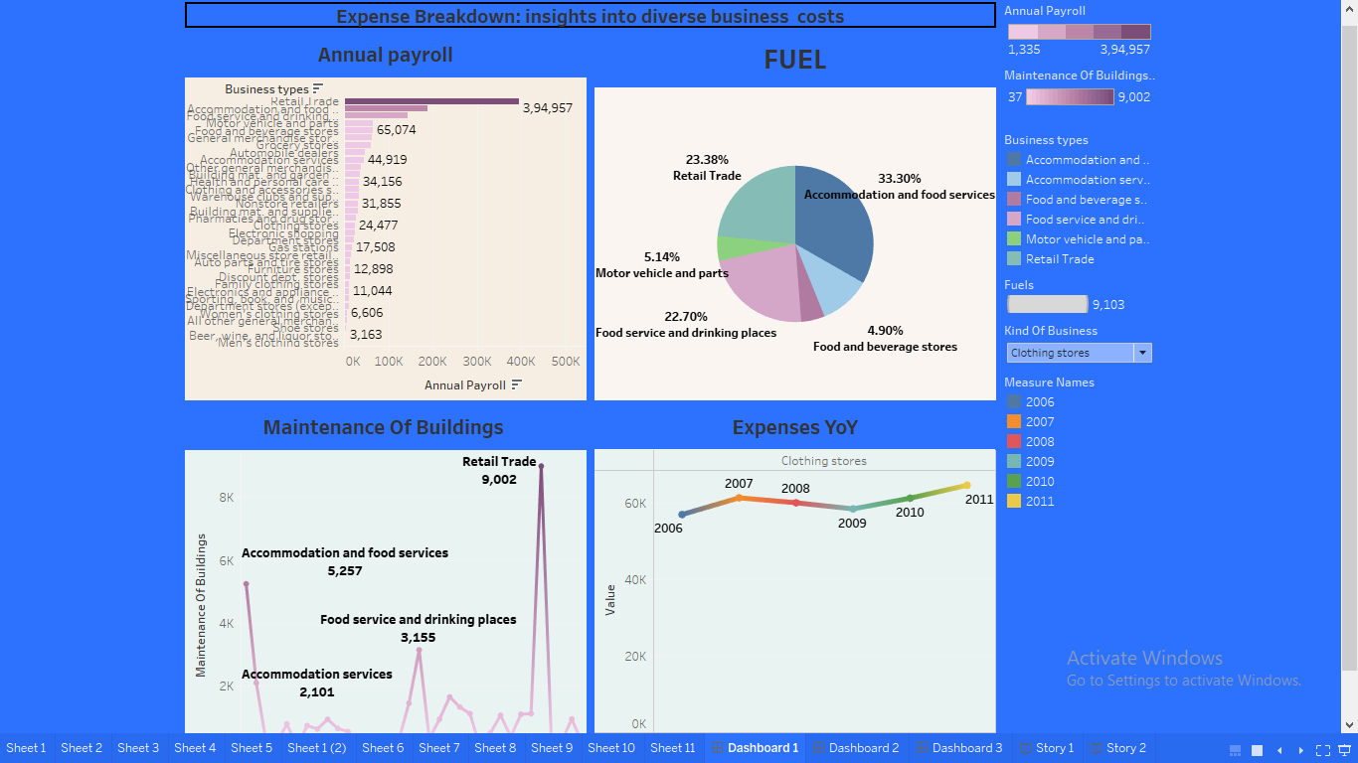

**Dashboard 2**

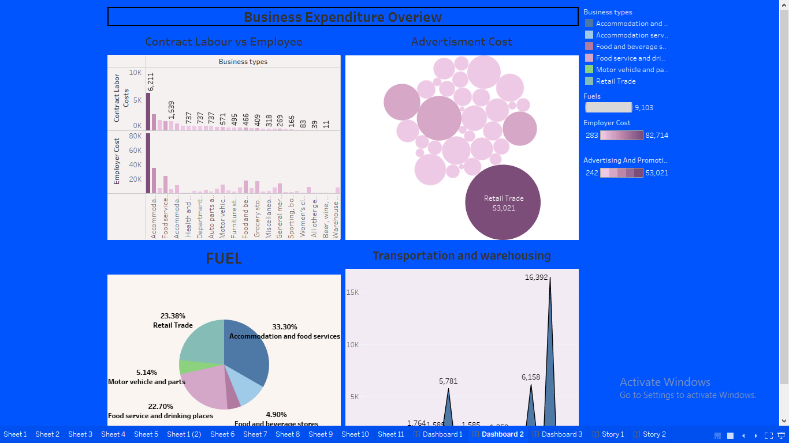

**Dashboard 3**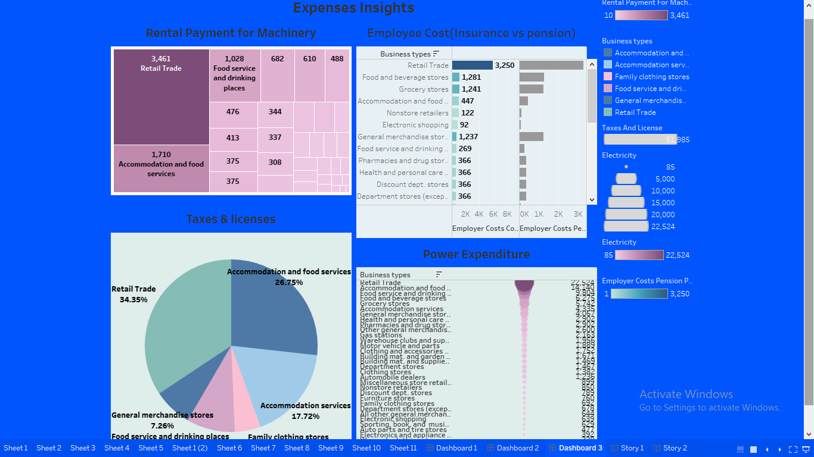

**Story 1**

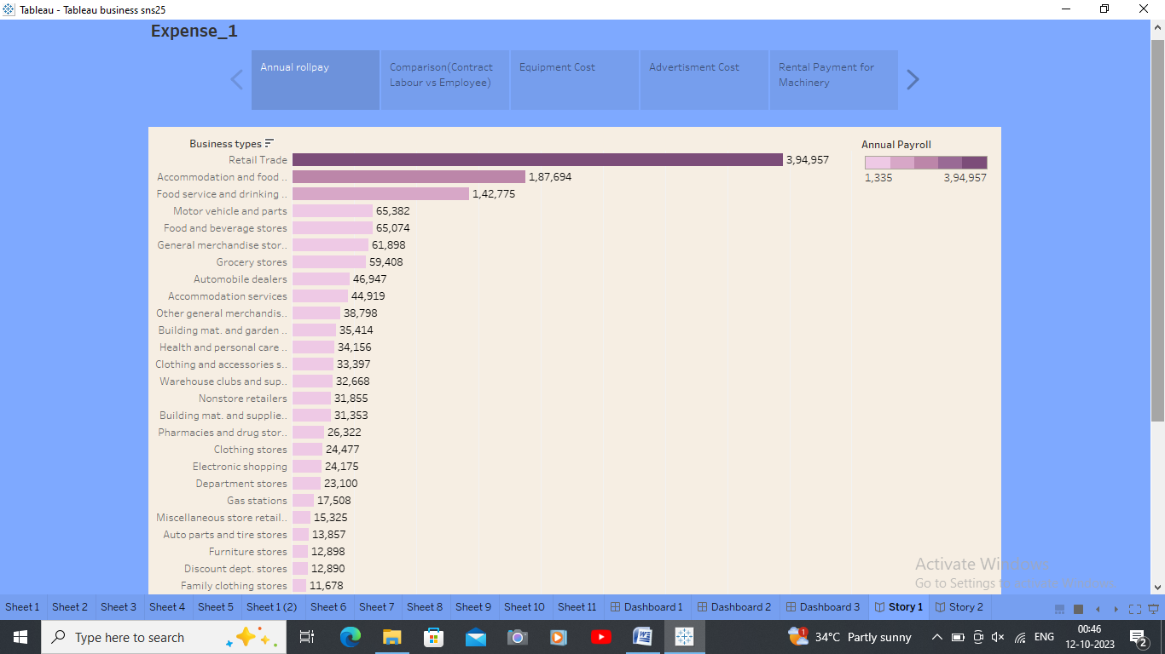

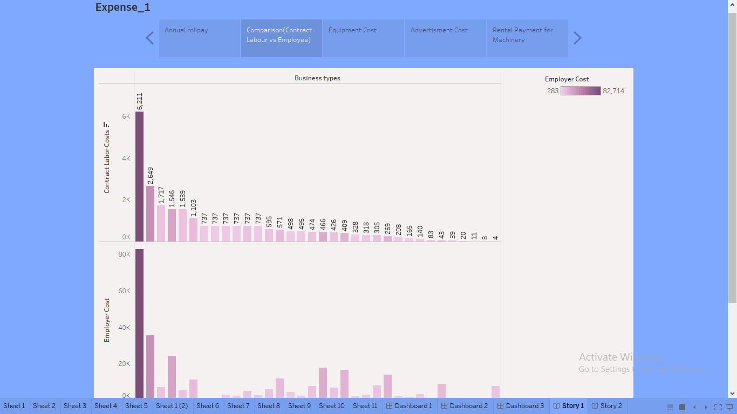

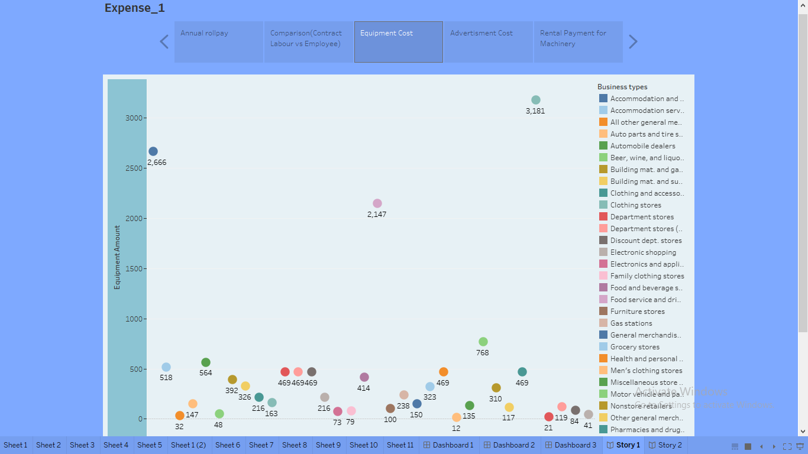

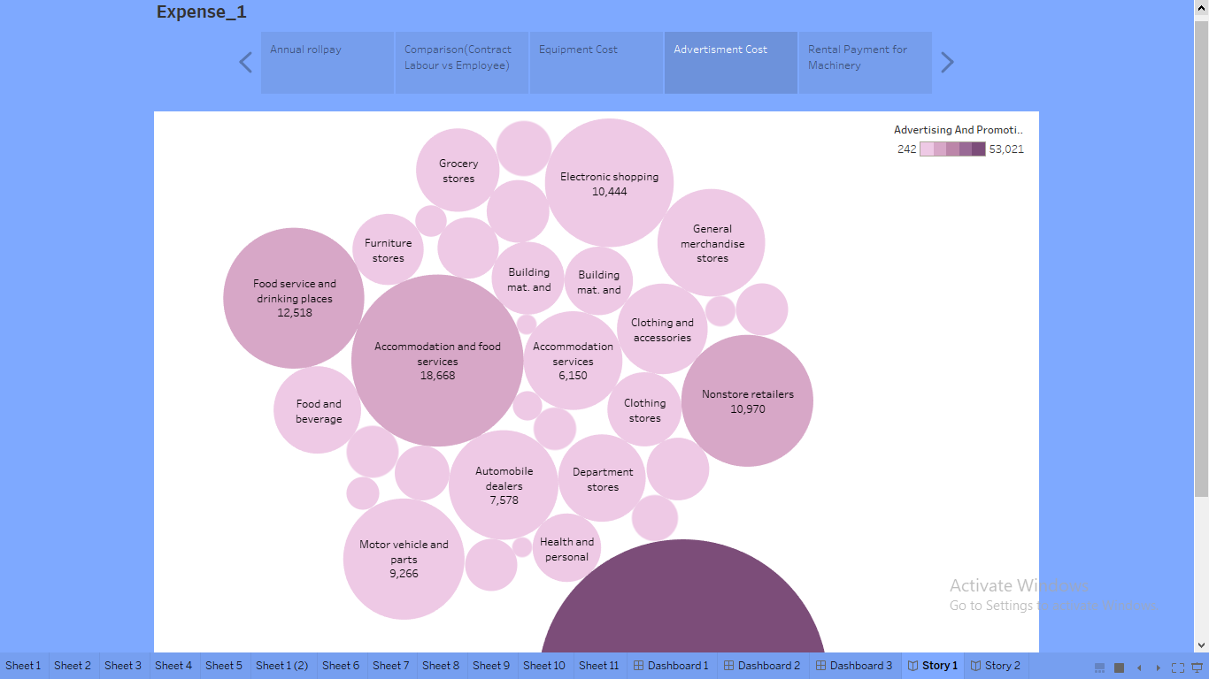

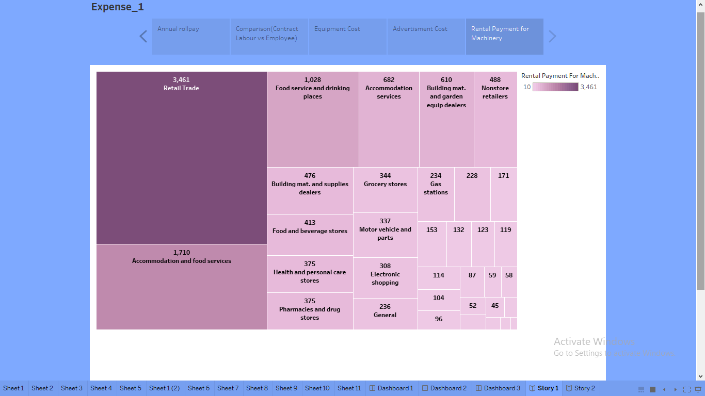

**Story 2**

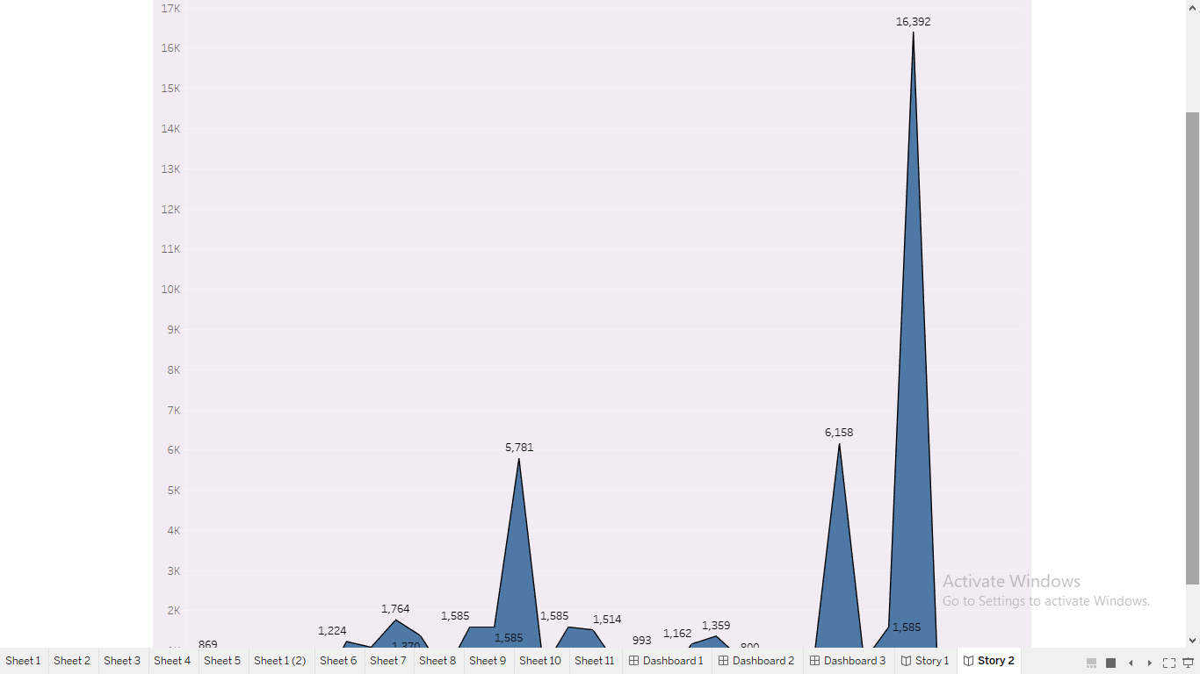

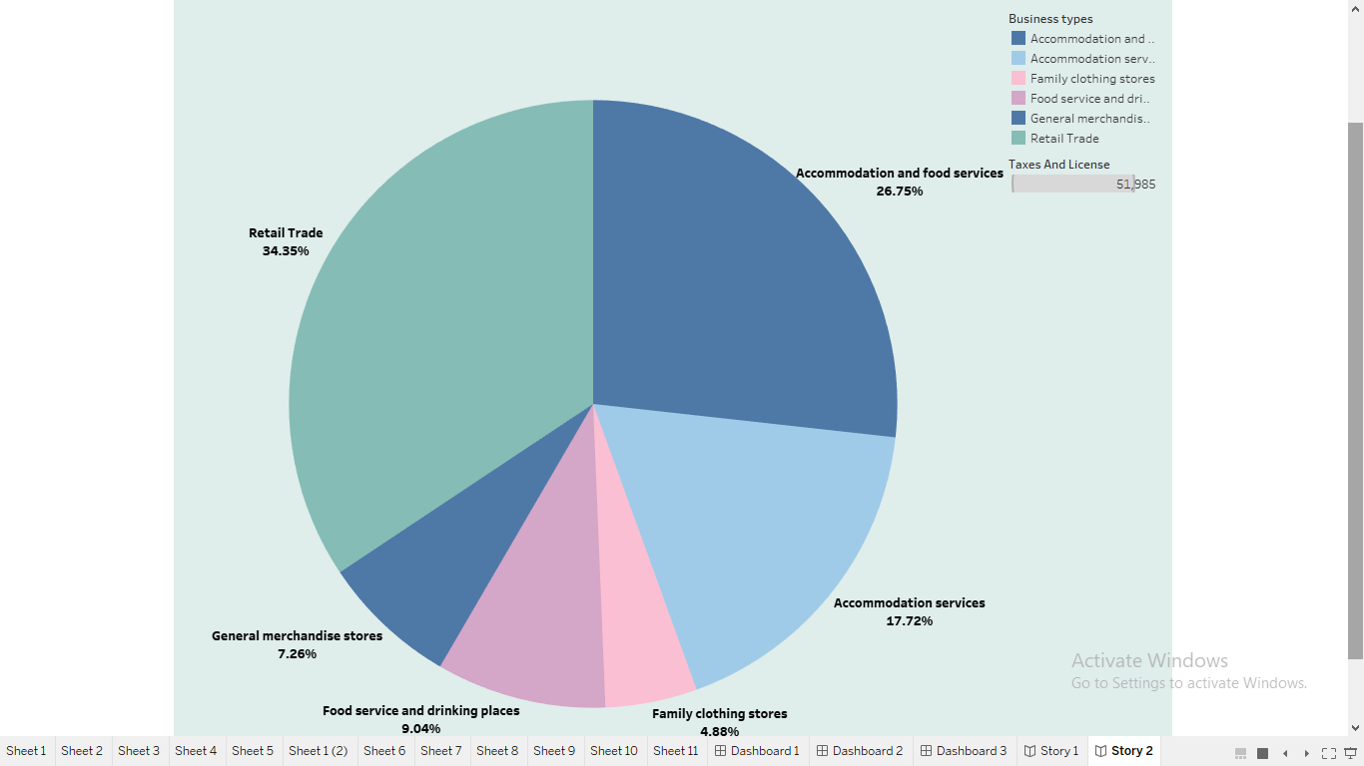

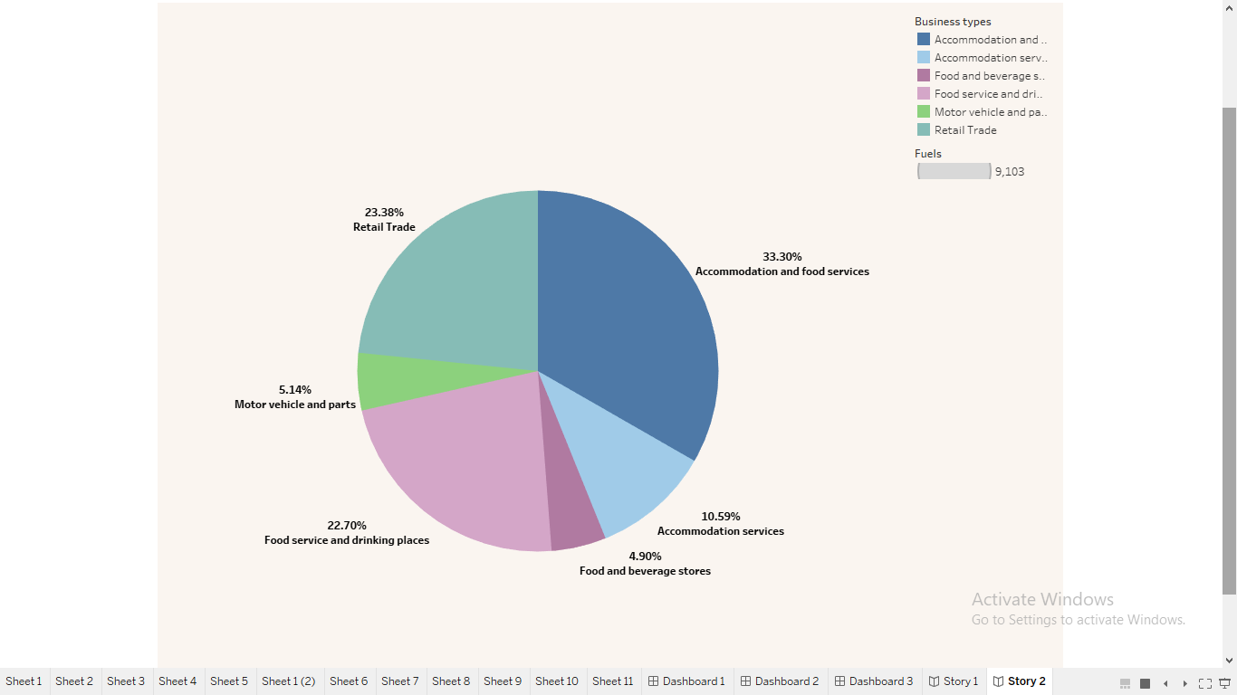

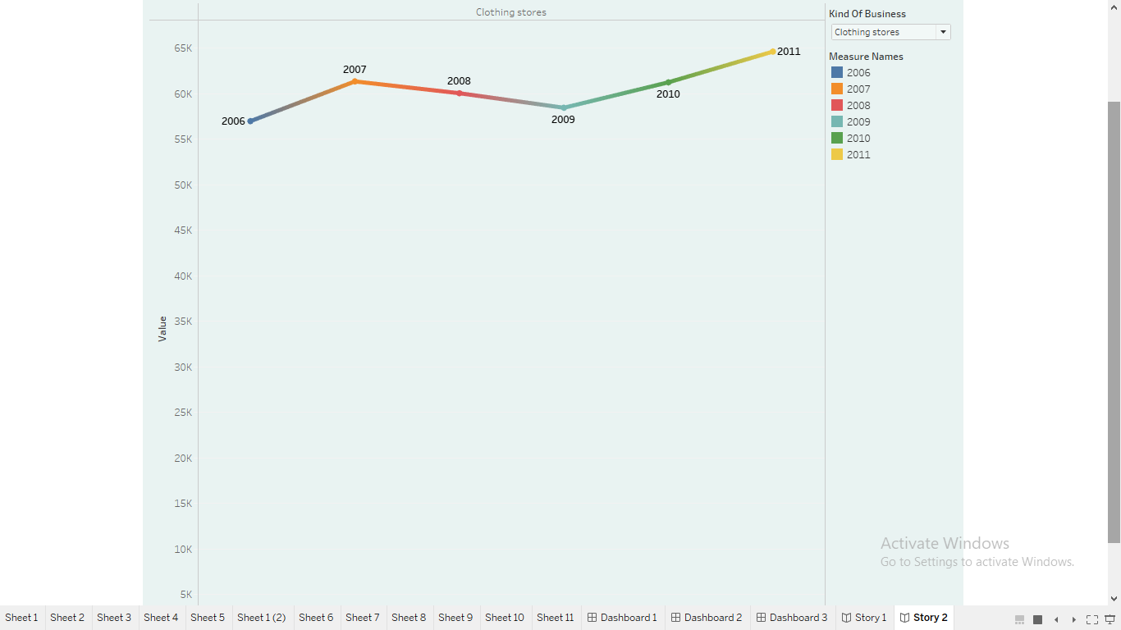

**Advantages:**

* + - **Accurate planning**
    - **Increased and improved profit margins**
    - **Improved resource management**
    - **Stronger customer relationship**
    - **Better reputation in the business**

**Disadvantage:**

* **This leads to** **constant changes in price, which means that costs have to be frequently updated and values changed to match**.